Glossary L
Return to main Glossary index

Latching
A pulse method to change the state from on to off or vice versa.
Dead Link Please Replace
Dead Link Please Replace

Layout Command Control
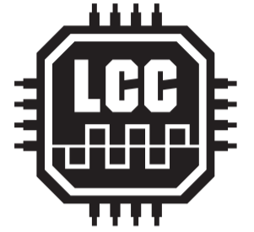
Layout Command Control (LCC) s a system for controlling all the functions on your layout that don’t have to do with how fast the locomotive is moving – things like signals, or sounds, or passenger car lighting. LCC is NMRANet, just under a different name. LCC is designed as a separate, generic control bus which is positioned to take the load off your throttle bus. It is a bi-directional data bus that can send and receive data. Since it is an NMRA Standard, you are not confined to one manufacturer's products. Any manufacturer can make LCC compatible devices.

Lead free
This is a change in the content of solder. Lead free solder is generally recommended due to Health and Safety considerations, but 60:40 tin:lead is preferred for electronic kits and is still available from suppliers such as Rapid Electronics.

LED
Light Emitting Diodes (LEDs) emit light when an electric current passes through them
 \\Circuit symbol:

http://www.merg.org.uk/merg_resources/led.php
http://www.kpsec.freeuk.com/components/led.htm

LENZ
A German dcc system and decoder manufacturer

Lighting decoder
A DCC decoder made especially for lights for a loco or carriages.

Logic
In a model railway it is a way to do step by step sequence to make the train do what you require.
Logic
Logic Gates

