Replace Somewhere with the name of your area group.

MERG Virtual Area Group
Area Groups Public pages MERG Home page
Replace photo with a area group meeting photo
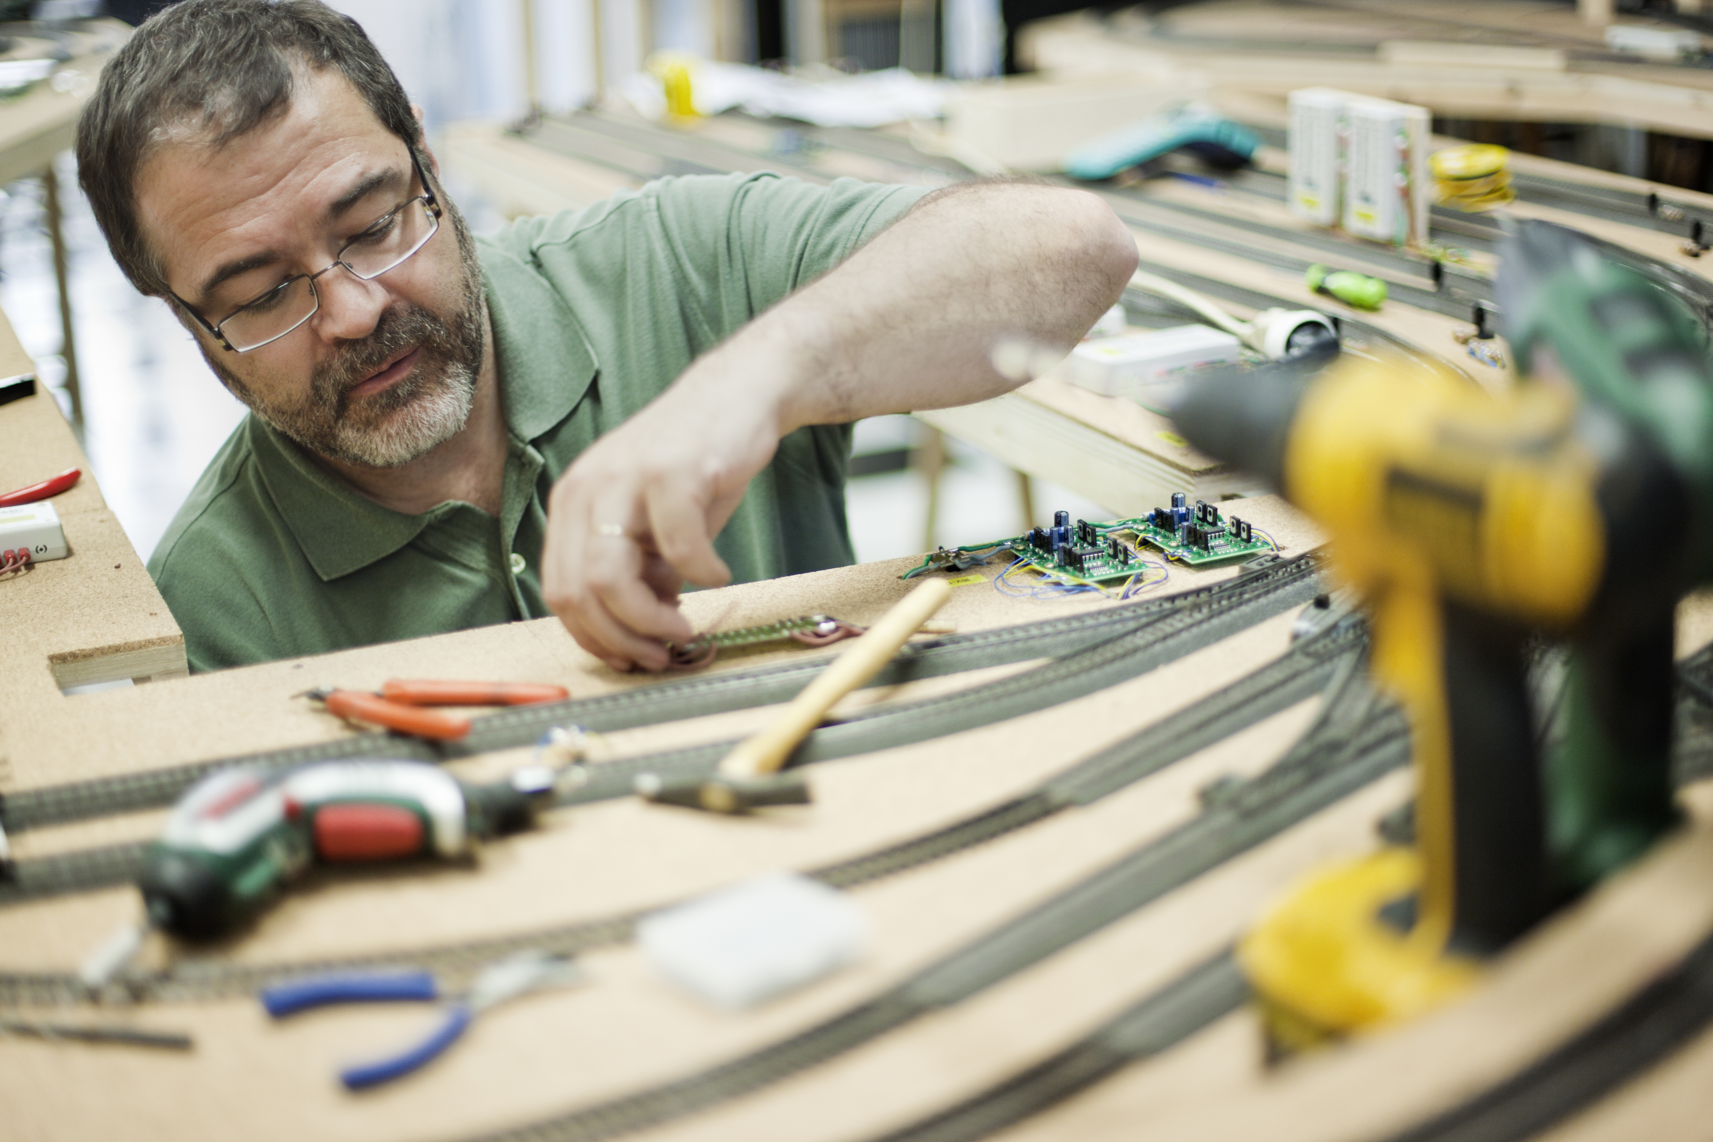

How do I contact the Virtual Area Group?
* Replace NN with the number of your area group - get from the AG admin page. Update the contact form title. *
MERG Virtual Area Group contact form

Who is the leader of the group?
Replace photo with the names and titles of leaders.
Dave Mason, who is a retired chartered engineer with relevant experience in electronics and control system software, but little experience with railways, model or otherwise. Dave is a member of the South Hants Area Group and piloted the first virtual Special Interest Group exploring “analogue/DC” systems.
(“Acemason” on the Forum. Website: www.townace.plus.com)

Would you like to join today?
Update area group name.
Not a member? then
Join MERG Here
and sign up to this Area Group. If you are already a member
Join the Virtual Area Group
Select Virtual Area Group from the drop down list in Other Area Groups and press the Subscribe to Area Group button.

How do you meet?
Provide meeting details
The Virtual Area Group (VAG) is for MERG members only and was started primarily for those too distant from their nearest Area Group. It only meets using Zoom.
During the first two years of the VAG we regularly welcomed members from Australia, Canada, Iceland, Ireland, UK, USA etc and varied weekly meeting times to try to make the calls work for different time zones.
Many Area Groups have switched to using Zoom during Covid and so, temporarily we hope, created many other options for joining in.
At the start of 2021, after a break in the programme and with those other MERG Zoom options which are accessible to members in the western hemisphere, the plan is to resume VAG meeting only once a month on a Tuesday at 10am UK time which suits members in Europe and the Australian times zones.
Meetings are nominally for an hour but typically Zoom will open 15mins before and for 30 mins afterwards for informal chat.
Calls may be recorded and made available all MERG members.

And the Next Meeting?
* Replace NN with the number of your area group - get from the AG admin page. Update the contact form title. *

How are Topics Chosen?
In April 2020 we carried out a poll of VAG members and the following topics were identified as the most popular: -
- How kits work - a series of calls, each discussing the how one particular kit works
- Types and use of baseboard connectors - covered in Demystifying Components -Wires and Connectors
- Oscilloscopes and logic analysers for hobbyists
- Using the FCU - a multi part course is being considered including the use of the FCU to configure individual 2nd generation modules.
- Testing boards (use of various pieces of test equipment and the way to go about it) - A Test Gear Buyers Guide has already been presented.
- Neater Methods of under board wiring
- Best practice for wiring different bus types
- Layout control buses
- CBUS wiring strategy on a large club O gauge layout
- CANPAN wiring
- Servo and Servo Mounts
- Building CANVOUT
- Prusa 3D Printer
- 3D scanners
- Photogrammetry - generating 3D models from multiple photographs
- CBUS Beginners Kit.
Members can suggest topics at any time using the member email system.

How do Video Calls Work?
To join in you may need to add a headset with microphone and optionally a camera to your device, if they are not built in. You will receive a link which will get you into the meeting, automatically installing Zoom on your device if necessary.
Calls are scheduled and topics announced in advance.
Zoom provides thumbnails of each video participant and any shared presentations or desktops. The call host facilitates the meeting/questions/discussion. Zoom has developed a lot during Covid and I can't describe all the features here.
Usually everyone mutes their microphone to avoid a lot of noise from phones, clocks chiming, family activity etc. To speak you can just press the spacebar to (after a slight pause) temporarily unmute. The host has power to mute if appropriate.
You can select among several icons to, for example raise a hand, clap, agree, vote etc. Useful for questioning.
You can also type “chat” either with everyone or with a selected participant. This is quite a good way to have a one-to-one conversation without involving/annoying everyone else. It can also be used to distribute weblinks etc although there are many other ways to “share” (with permission) screens, documents, open apps, whiteboard and so on.
If you would like to try out Zoom, then there is a test meeting service where you are the only participant and you can experiment with the various options available.
Test Zoom
This link is available to anybody, not just members of the virtual area group.

VAG Members Page

