Replace Somewhere with the name of your area group.

MERG East of Scotland Area Group
MERG Home page | Area Groups | More on our Knowledgebase | Group Members Page

Replace photo with a area group meeting photo
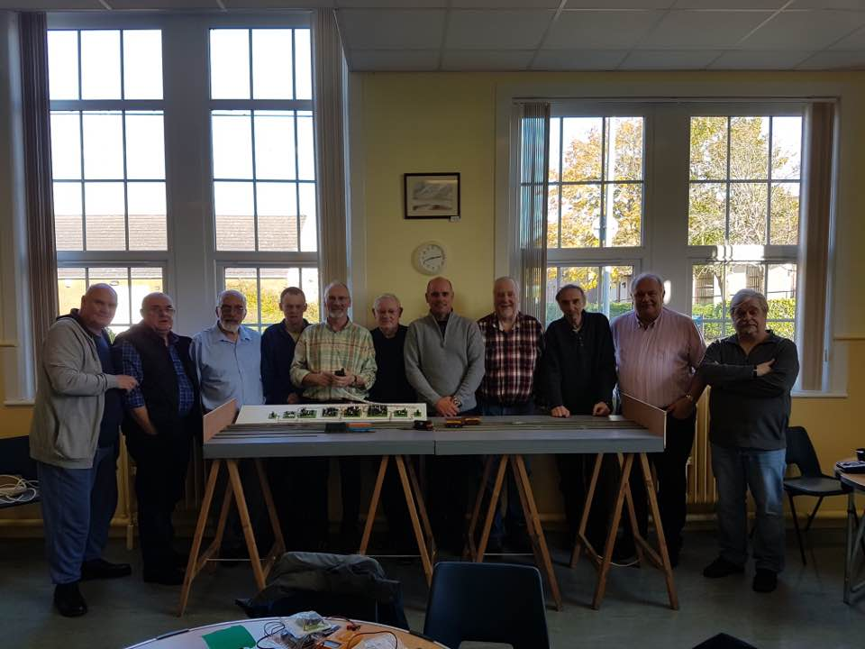
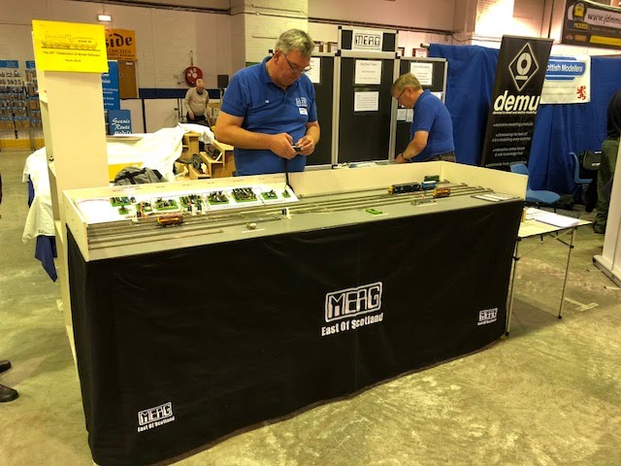

How do I contact the Area Group
Please indicate East of Scotland Area Group in your message Contact MERG

Who are the leaders of the group?
Replace photo with the names and titles of leaders.
Jim Hardie - Chairman
Alistair Fitchie - Secretary

Would you like to join today?
Update area group name.
Not a member? then
Join MERG Here
and sign up to this Area Group. If you are already a member
Join the East of Scotland Area Group
Select East of Scotland Area Group from the drop down list in Other Area Groups and press the Subscribe to Area Group button.

How do you meet?
Provide meeting details
Meetings are held around once a month at West Calder Community Centre. January (AGM), April, July and October.
These are more formal than the workshops but still remain a relaxed and inviting affair.
Here we can listen to down to earth talks on key parts of electronics in model railway layouts from people who really know their stuff.
It is a chance to quiz these people too and present our own experiences without fear of ridicule or embarrassment. They are experts for a reason - probably because as we are all experiencing going down the same journey - it is just that some have spend longer than others on that journey and are at different stations down the line.
Workshops are held around once a month 10:30 to 15:30.
We normally start with a coffee as everyone arrives and then chat through the aims of the day and who will do what and who will supervise and assist when needed.
Lunch does happen but the timing depends on what each of us is up to. But it is a good time to talk through issues you may be having with your home layout. No over-bearing advice - just friendly options.

And the Next Meeting?
* Replace NN with the number of your area group - get from the AG admin page. Update the contact form title. *

</WRAP>
MERG Home page | Area Groups | More on our Knowledgebase | Group Members Page

