MERG Three Counties Area Group

Buckinghamshire, Bedfordshire and Hertfordshire
MERG Home page | Area Groups | More on our Knowledgebase | Group Members Page

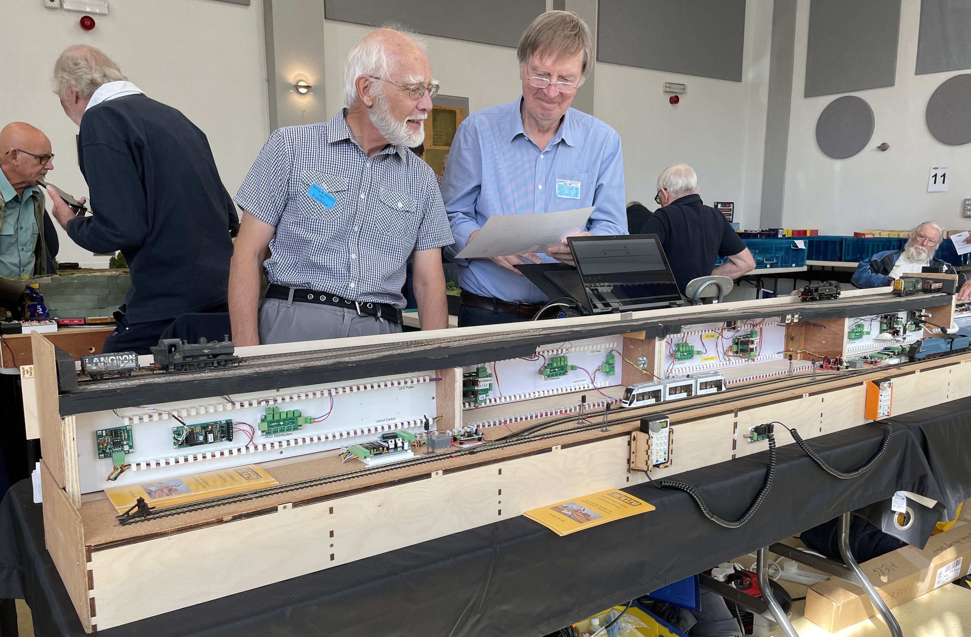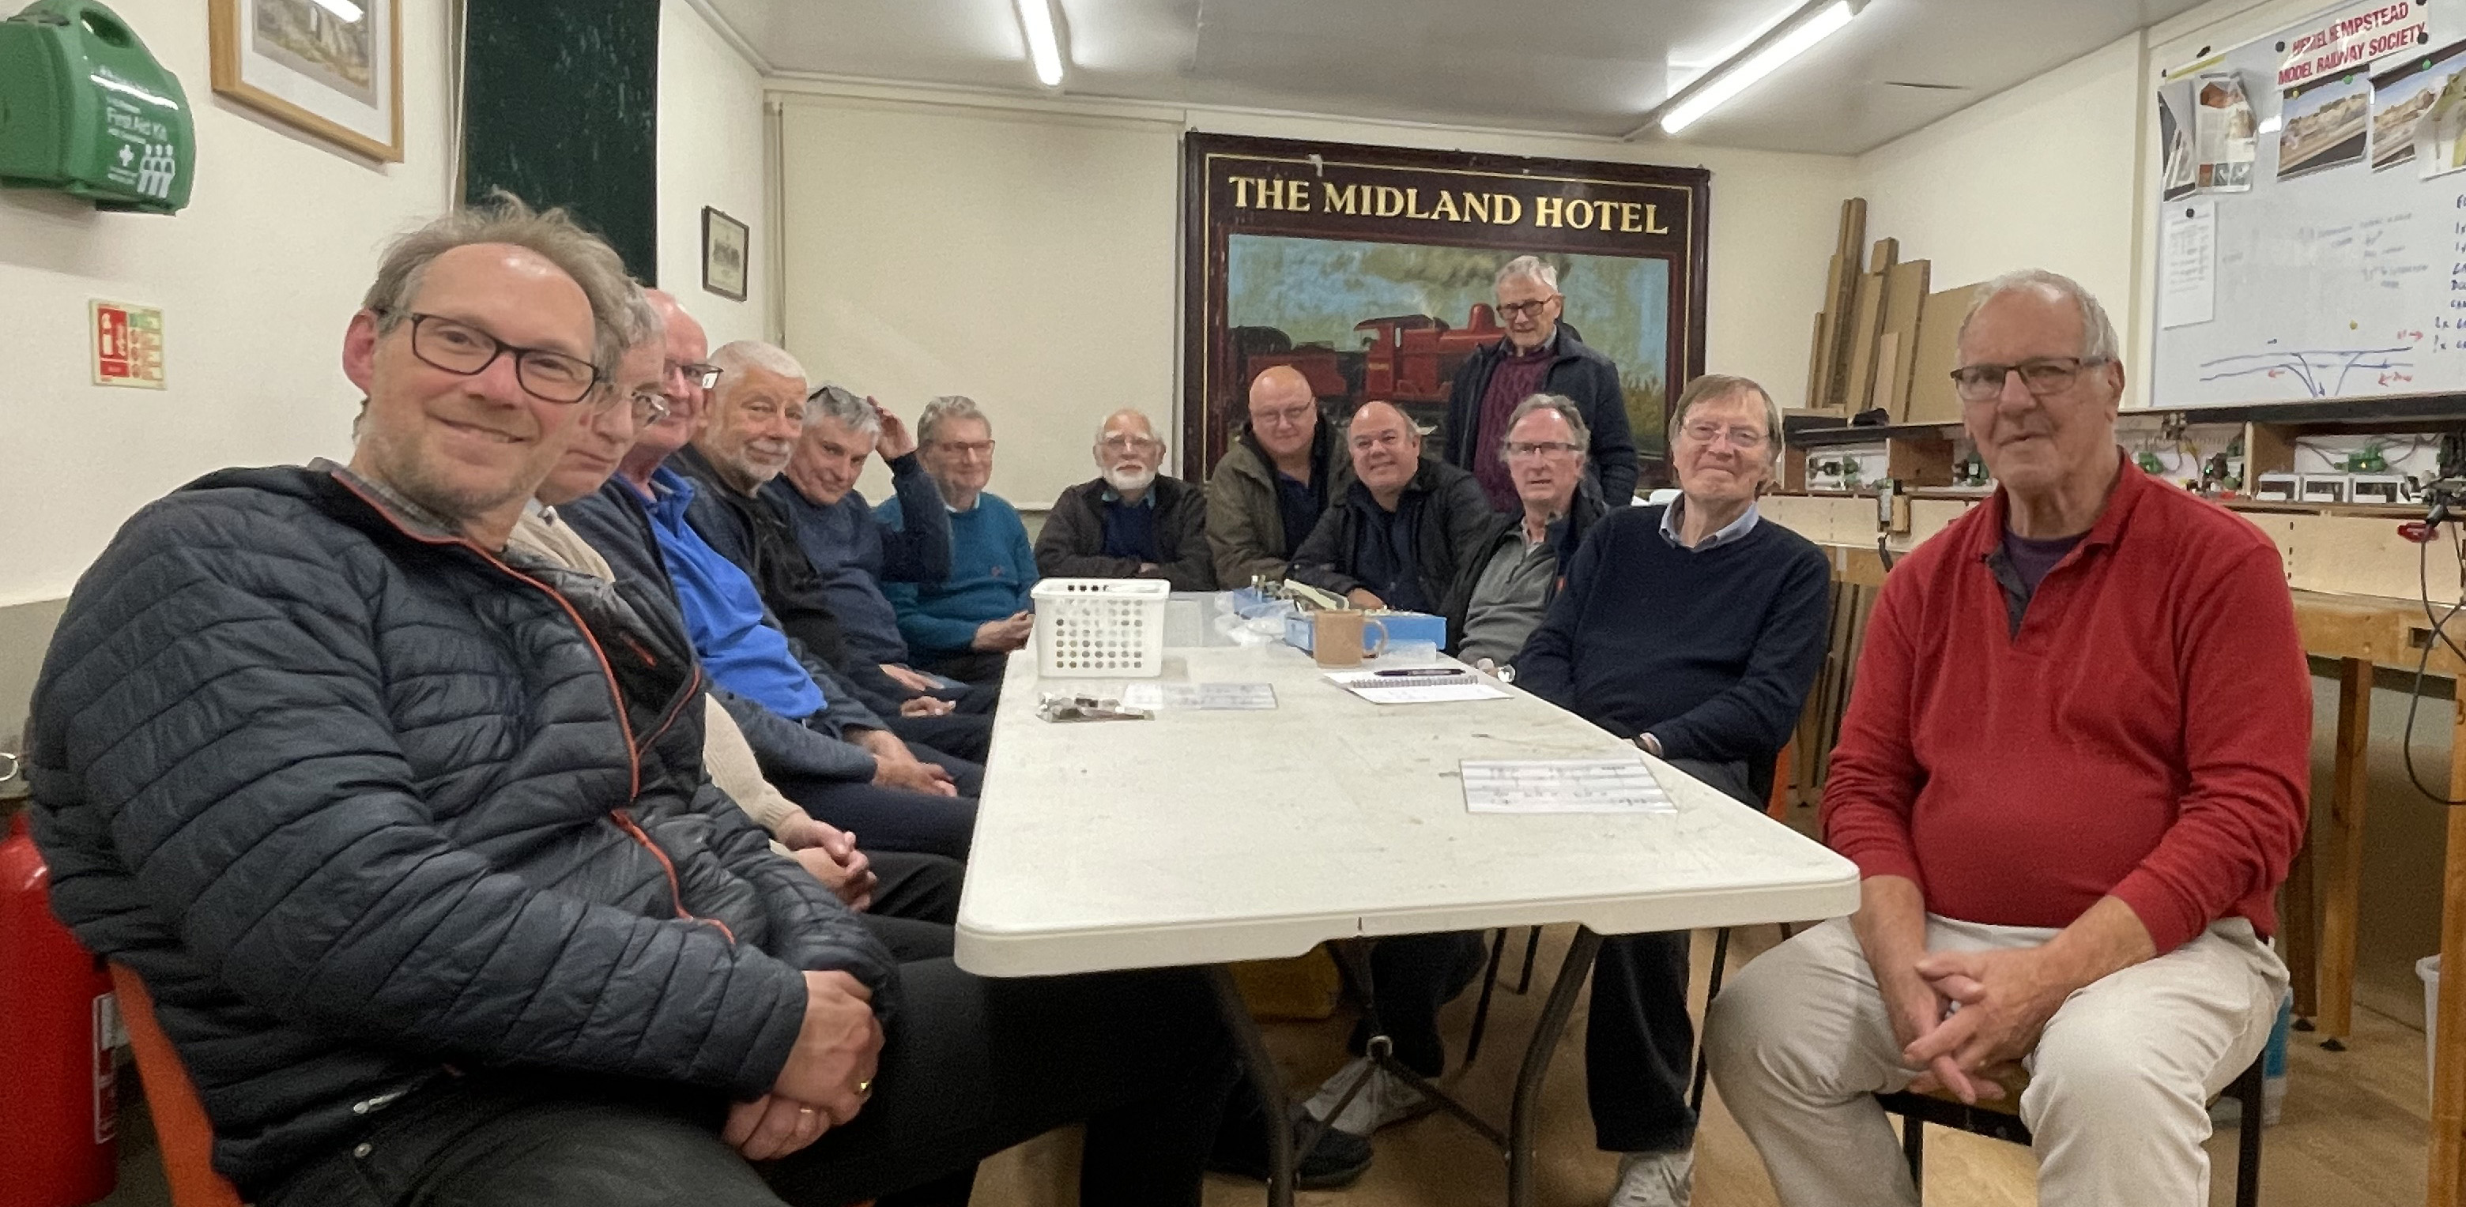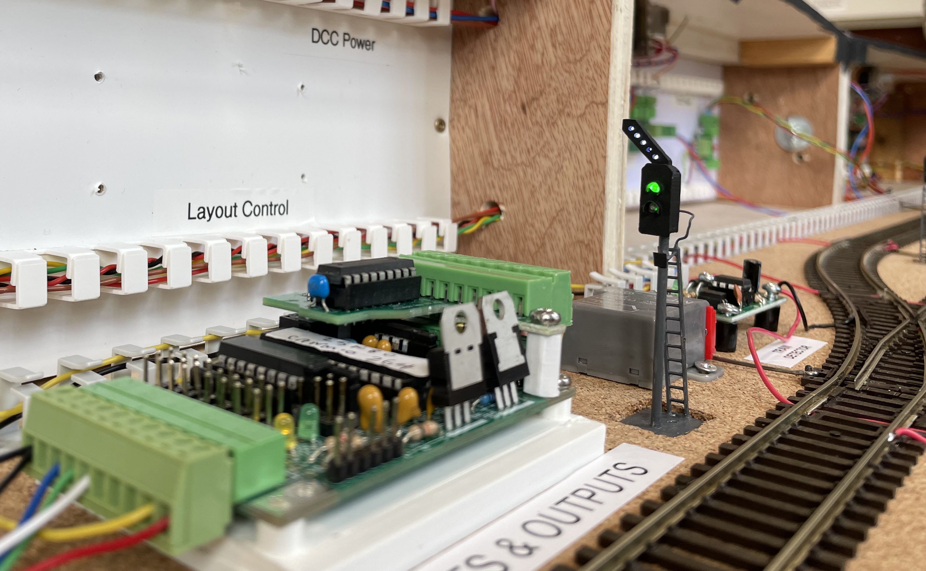

About the Three Counties Area Group
Group members are drawn from the three home counties of Bedfordshire, Hertfordshire and Buckinghamshire.
Most members belong to other model railway clubs in this area, but we share a common interest in the use of technology to enhance model railway layouts.
We meet on a regular basis to exchange ideas and expertise.

How do you meet?
We meet monthly over Zoom or in person at the Hemel Hempstead Model Railway Society clubhouse:
Nash Mills Recreation Centre, Off Red Lion Lane, Hemel Hempstead HP3 9TE
http://www.hhmrs.co.uk/contact.htm
Meetings usually include some or all of the following:
- A presentation
- A session on a group project
- A practical workshop
- Requests for help

Details of upcoming meetings
We welcome new members.

How do I contact the Area Group
Please indicate Three Counties Area Group in your message Contact MERG

Who is the leader of the group?
Area Group Leader: Christopher Langdon
Assistant Area Group Leader: Robert Thomas

Would like to join today?
Not a member? then
Join MERG Here
and sign up to this Area Group. If you are already a member
Join the Three Counties Area Group
Select Three Counties Area Group from the drop down list in Other Area Groups and press the Subscribe to Area Group button.

How do you meet?
Whilst restrictions are in place, we are using Zoom video calls.
Previously we met at three different locations: -
Eaton Bray Village Hall
Church Lane, Eaton Bray, Dunstable, LU6 2DJ
Guide in map
Risborough & District Model Railway Club
Meetings held at Risborough Community Centre HP27 9AX
Club website
Hemel Hempstead Model Railway Club
Meetings at the Club, Off Red Lion Road, Hemel Hempstead HP3 9TE
http://www.hhmrs.org/contact.html
Meetings include some or all of the following:
- A presentation
- A session on a group project
- A practical workshop.

And the Next Meeting?
To join our Zoom Meeting, logon to the MERG website and go to the Start Page
https://www.merg.org.uk/merg_wiki/doku.php
From there, look at My Upcoming Events and providing that you are a member of 3 Counties , you will see the link for the meeting.

Where Have I Seen Ealing Road?
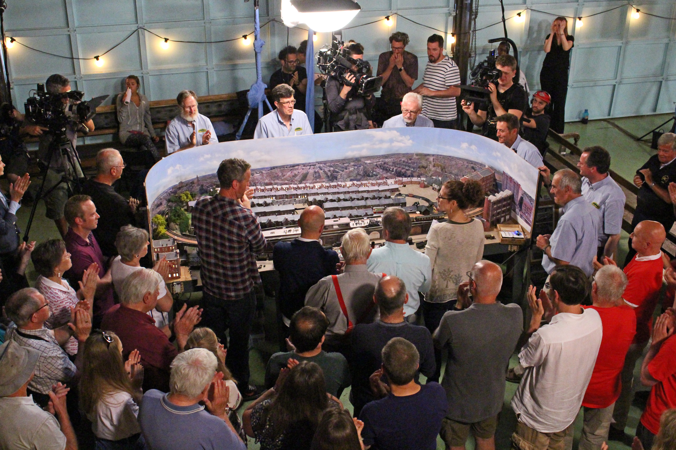
The group supplied expertise and manpower to mount an entry to the 'Great Model Railway Challenge' and Missenden Modellers as its identity (the Bucks County adult education centre at Great Missenden offers railway modelling courses). Their 'Ealing Road' layout featured MERG components and has subsequently been exhibited on a number of occasions and featured in the Model Railway press (an edition of British Railway Modeller). A description of this (and other MERG related entries to the challenge) appeared in the MERG journal Vol 52 December 2018.
MERG Home page | Area Groups | More on our Knowledgebase | Group Members Page

