MERG Northern Ireland Area Group (NIAG)
MERG Home page | Area Groups | More on our Knowledgebase | Group Members Page

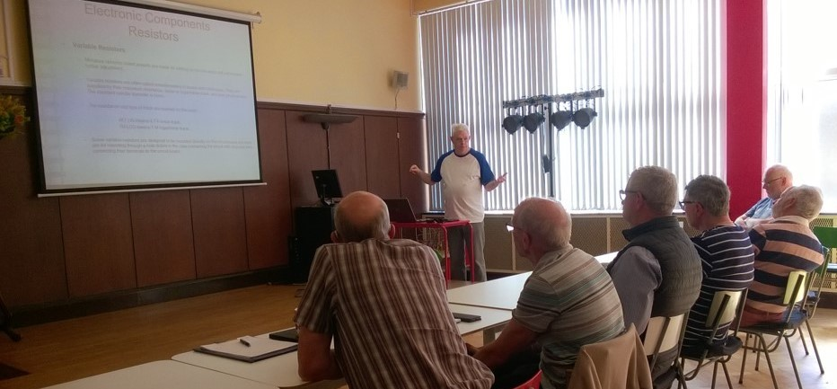Some basic electronics training.

How do I contact the Area Group
Please indicate Northern Ireland Area Group in your message Contact MERG

Who are the leaders of the group?
Philip Griffiths M10359 Leader
Jim Gregg M2375 Treasurer
John Gough M4181 Hon Secretary

Would you like to join today?
Not a member? then
Join MERG Here
and sign up to this Area Group. If you are already a member
Join the Northern Ireland Area Group
Select Northern Ireland Area Group from the drop down list in Other Area Groups and press the Subscribe to Area Group button.

How do you meet?
We meet on the 1st Saturday of each month at 2pm in Cooke Centenary Presbyterian Church Halls, Park Road, Ormeau Road, Belfast BT7 2FY.
Meetings are usually a mix of workshop and help sessions with more formal teaching / learning sessions or presentations based on topics requested by the Members.
Tea and Biscuits are on tap throughout the meetings for a small attendance charge.
​All members are welcome and anyone interested in joining our Area Group is welcome to test us out at any meeting. Just use the contact details above to make arrangements.

And the Next Meeting?

Exhibitions
We normally exhibit at all the major shows across the Province:
- Bangor - at both the North Down MRC and 1st Bangor MRC,
- Belfast - at the Ulster Model Railway Exhibition,
- Enniskillen - at the Erne Model Railway Exhibition,
So keep a lookout for shows in your area. Come to the stand and say Hello.
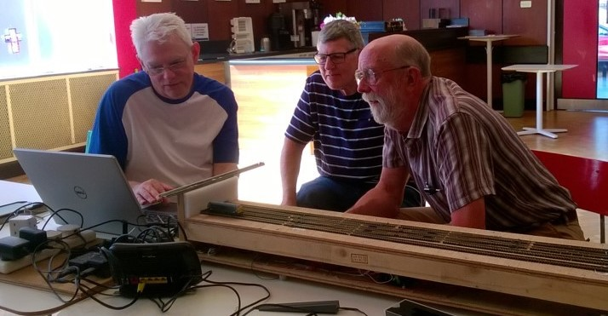
MERG Home page | Area Groups | More on our Knowledgebase | Group Members Page

