PECO 3 way point
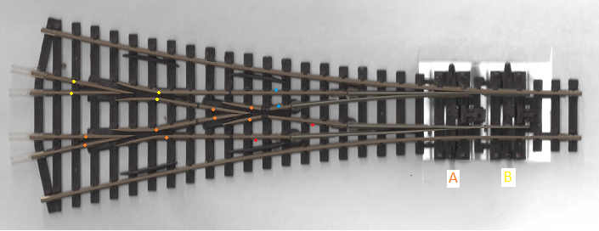
The example shown below has recently been extracted from a defunct club layout and is about 20 years old, today's version may be different.
The left hand frog and the central frog are bonded together and a wire is attached which may be passed down through the base board or led out to the side via a channel provided for that purpose. The rails concerned are indicated here by an orange spot. Switching of this pair of frogs would be in unison with the tie bar marked A.
The right hand frog has a similar wire attached and likewise this may be passed down through the base board or fed out to the side. The rails concerned are indicated with a yellow spot. This frog is switched in unison with the tie bar marked B.
The switch rails are isolated from the frogs and pick up their current via small wipers which contact the under side of the appropriate stock rail. If you wish to bond these to the stock rails so as not to rely on the wipers then each will require a wire soldered to the outside edge of the fixed part. These four places are indicated by two red spots and two blue spots.

