Replace Somewhere with the name of your area group.

MERG Aberdeen Area Group
Area Groups Public pages MERG Home page
Replace photo with a area group meeting photo
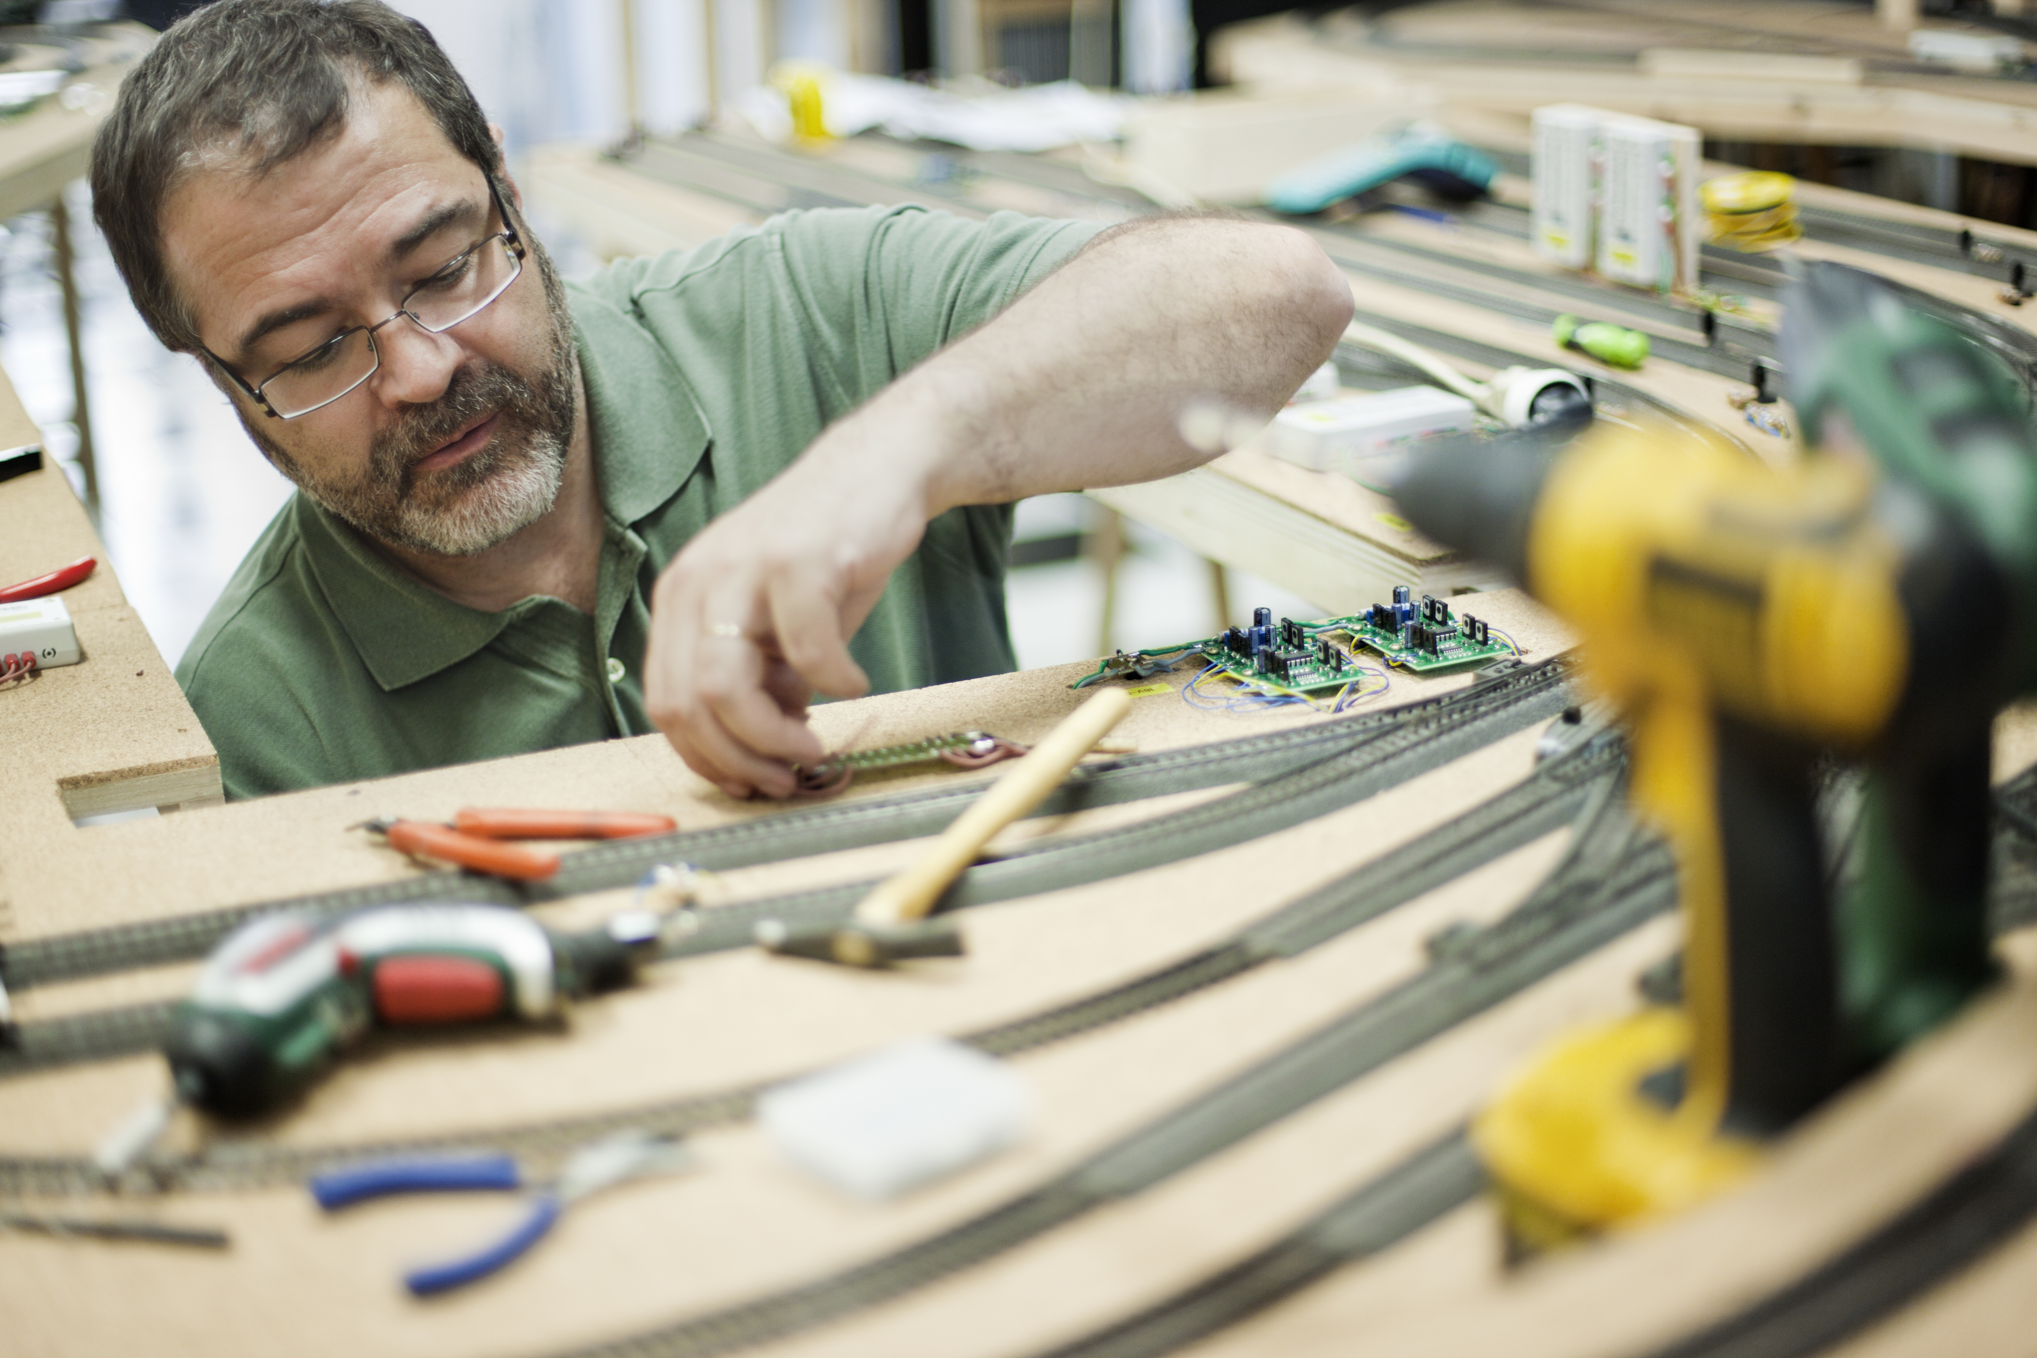

How do I contact the Area Group
* Replace NN with the number of your area group - get from the AG admin page. Update the contact form title. *
MERG Aberdeen Area Group contact form

Who are the leaders of the group?
Replace photo with the names and titles of leaders.
Colin Stevenson

Would you like to join today?
Update area group name.
Not a member? then
Join MERG Here
and sign up to this Area Group. If you are already a member
Join the Aberdeen Area Group
Edit Area Groups using the green pencil. Then select Aberdeen Area Group from the drop down list in Other Area Groups and press the Subscribe to Area Group button.

How do you meet?
Provide meeting details
Whilst restrictions are in place, we are using Zoom video calls.
Previously we met on the third Thursday evening of the month at the Aberdeen Model Railway Club premises on the Ferryhill Railway Heritage Trust site near the centre of Aberdeen. Meetings will resume as soon as it is safe to do so. In the meantime, please get in touch by email.

And the Next Meeting?
* Replace NN with the number of your area group - get from the AG admin page. Update the contact form title. *

Local Links
Link to local model railway sites.
Ferryhill Railway Heritage Trust
Aberdeen Model Railway Club
KMS Railtech - Inverurie

