MERG related courses
If you know about any other relevant courses not listed here, in particular those in other areas, please add them.
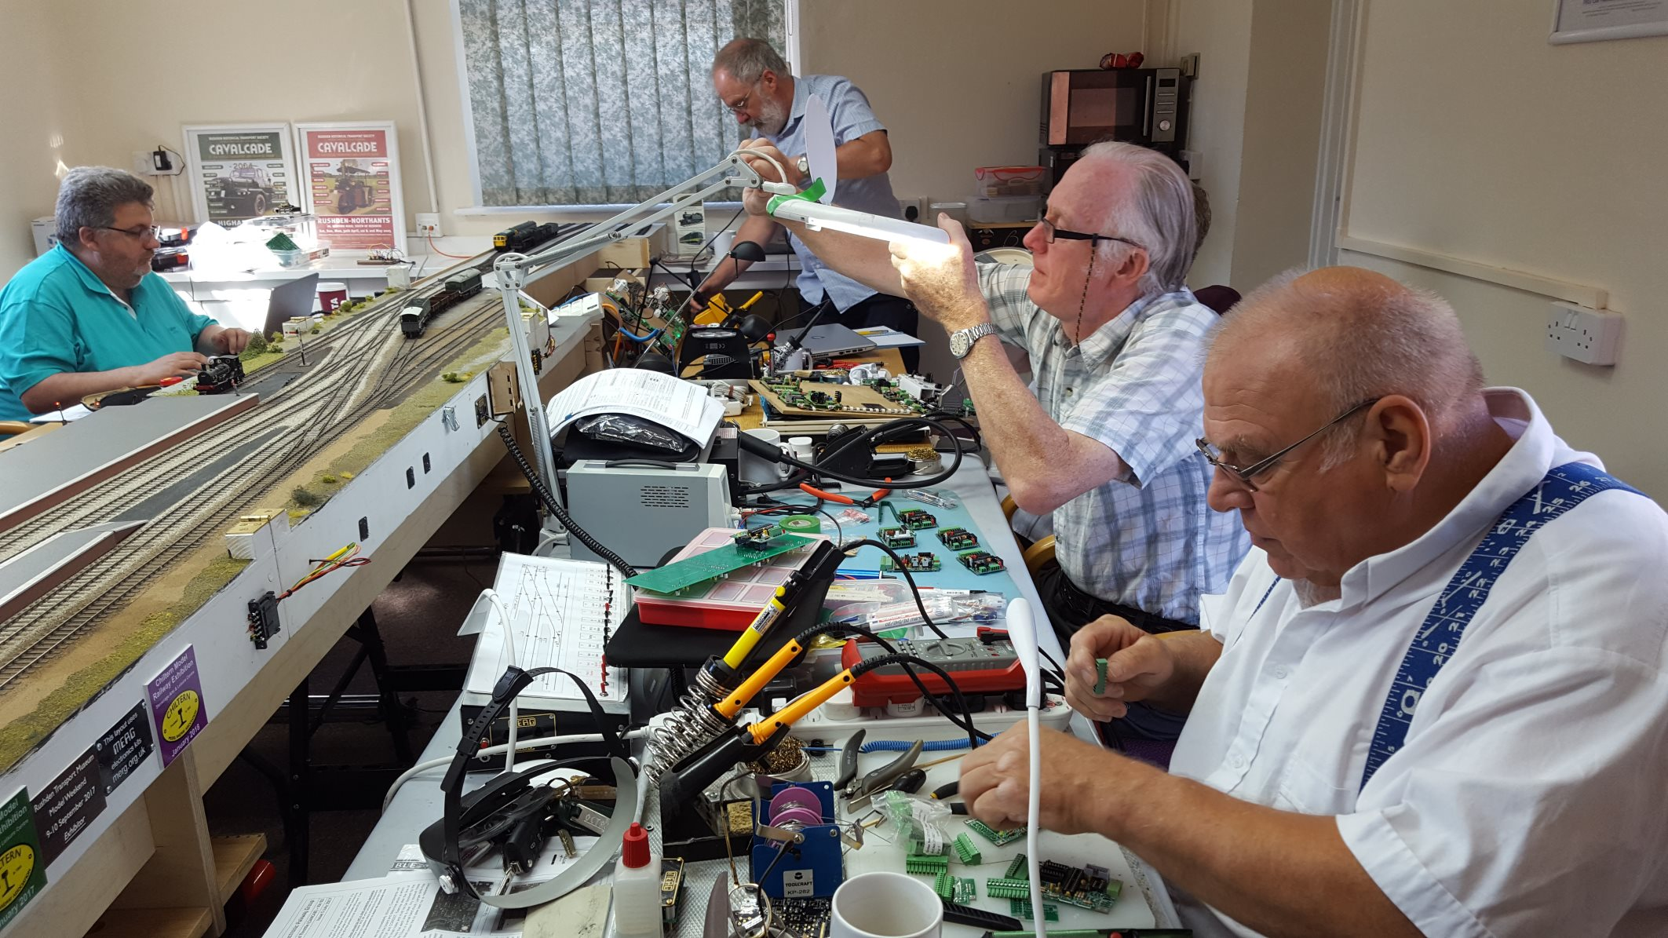
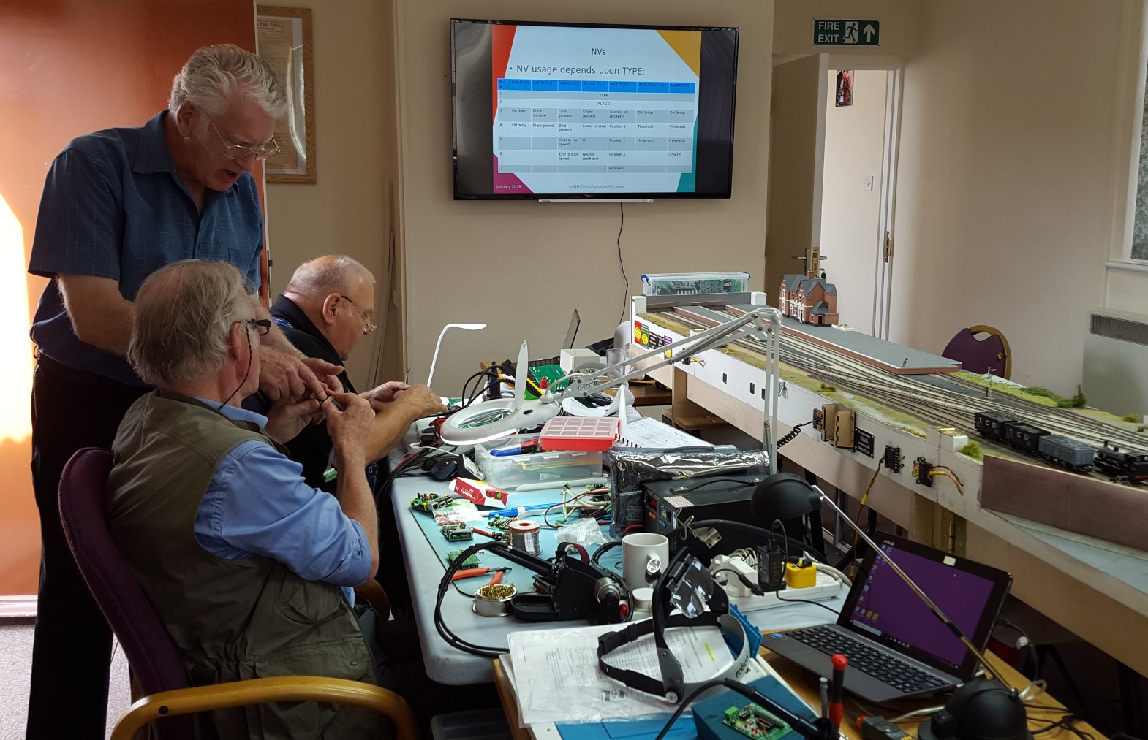
Note that you do not have to be a MERG member to come on these courses.
These courses are organised by a group of MERG members for the benefit of other MERG members and railway modellers in general. Your booking is directly with the course organisers, not with MERG itself.
All bookings for courses that were postponed over the last couple of years will be honoured for future courses.
If you already have a booking for any course, you will be contacted directly by email about the arrangements and dates.
The dates for 2022 are now confirmed with the venues.
See also the list of possible courses for 2023.

Missenden Railway Modellers Spring weekend - 4-6th March 2022
The Missenden March weekend 2022 has now been scheduled, and bookings are open.
See the website for more details:
Missenden Railway Modellers weekend

Introduction to CBUS
12-14th March 2022
The course took place in the “Goods Shed” meeting room at the Rushden Transport Museum & Railway, Rushden Station, Northamptonshire.
See the list, at the bottom of this page, of possible courses for 2023, and if you are interested in this or another course next year, please let us know.
What this space for when the next course is scheduled.
For those just starting out in CBUS, this weekend course will take you from first principles through building CBUS kits to setting up CBUS operations.
This course assumes no previous knowledge of CBUS.
Click below for more details:
Introduction to CBUS weekend course details

JMRI Decoder Pro – Programming DCC locos and managing the roster
19-21st March 2022 (Rushden) - Postponed from January
The course took place in the “Goods Shed” meeting room at the Rushden Transport Museum & Railway, Rushden Station, Northamptonshire.
See the list, at the bottom of this page, of possible courses for 2023, and if you are interested in this or another course next year, please let us know.
What this space for when the next course is scheduled.
This is a weekend course on making use of JMRI Decoder Pro software to program your DCC locos, and how to make use of the features of the loco roster.
A familiarity with basic DCC concepts is assumed.
Click below for more details:
Decoder Pro course details

More CBUS
23rd-25th April 2022
The course took place in the “Goods Shed” meeting room at the Rushden Transport Museum & Railway, Rushden Station, Northamptonshire.
See the list, at the bottom of this page, of possible courses for 2023, and if you are interested in this or another course next year, please let us know.
What this space for when the next course is scheduled.
This course is for those already familiar with the basics of CBUS, who would like to take it further.
Particular emphasis on configuring CBUS in FLiM and using the universal CANMIO firmware.
This course assumes that you have attended the Introduction to CBUS course, or that you already have a good understanding of the basics of CBUS, building modules and getting them working.
Click below for more details.
More CBUS weekend course details

JMRI Part 1 - STARTING OUT WITH JMRI PANEL PRO
16-18th July 2022 - NEW DATE!
The course will take place in the “Goods Shed” meeting room at the Rushden Transport Museum & Railway, Rushden Station, Northamptonshire.
JMRI is free software that you can download to control your model railway.
The course assumes no previous knowledge of JMRI and takes you through from first principles.
Click below for more details.
Starting out with JMRI Panel Pro course details

Missenden Railway Modellers Summer Retreat - 7-13th August 2022
The Missenden summer retreat is 7 days of uninterrupted modelling. Although there is not usually specific electronics content, there are generally some modellers working with electronics and experts on hand to assist with whatever you are working on.
See the website for more details:
Missenden Railway Modellers

JMRI Part 2 – Blocks, Routing, Logic and Signalling
10-12 September 2022
This is part 2 of our three JMRI courses.
The course will take place in the “Goods Shed” meeting room at the Rushden Transport Museum & Railway, Rushden Station, Northamptonshire.
This is a weekend course for those already familiar and competent with the basics of JMRI.
As a pre-requisite you should have attended our introduction to JMRI Panel Pro course, or be fluent with drawing a layout diagram in the Layout Editor, setting up turnouts & sensors, turnout feedback, linking from a Layout Editor Panel to the physical layout & the basics of train detection.
Click below for more details:
JMRI Part 2 – Blocks, Routing and Signalling course details

JMRI Part 3 – Automation with scripts and the Dispatcher
22-24th October 2022 (Rushden)
This is part 3 of our three JMRI courses.
This is a weekend course for JMRI power users who want to take it on to partial or full automation.
The course will take place in the “Goods Shed” meeting room at the Rushden Transport Museum & Railway, Rushden Station, Northamptonshire.
As a pre-requisite you should be a fluent JMRI user, having attended our Introduction and part 2 courses, or be comfortable with setting up panels in the Layout Editor, blocks and train detection, pathing and signalling.
Click below for more details:
JMRI Part 3 – Automation with scripts and the Dispatcher course details

Missenden Railway Modellers Autumn weekend - 4-6th November2022
The Missenden Autumn weekend 2022 has now been scheduled, bookings open on 10th May.
See the website for more details:
Missenden Railway Modellers weekend

POSSIBLE COURSES FOR 2023
For 2023, we are publishing a list of our Northamptonshire courses and inviting expressions of interest. We will then run a selection of those courses for which there is most interest.
Here are the possible courses we have thought of so far, we could run up to 6 courses that generate sufficient interest:
- General kit building workshop weekend
- Introduction to CBUS development
- Programming PICs
- Programming Arduinos
- Our usual Intro and More CBUS courses
- Our usual 3 JMRI courses, Intro, signalling/logic & automation
- Introduction to DCC
- Decoder Pro
- PCB Design
- 3D printing ++
- Weathering
- Build a MERG DCC system in a weekend
- Templot
++ Subject to finding a tutor
The courses would take place at one of our venues in Northamptonshire.
If you are interested in one or more of the above, and would most likely come if we ran that course, please drop an email to eastmids@merg.org.uk
If you are interested in a course that is not on the above list, please also send us an email, we may well add it to the list.

Links
Back to public pages index

