Replace Somewhere with the name of your area group.

MERG South Hampshire Area Group
Area Groups Public pages MERG Home page
Replace photo with a area group meeting photo
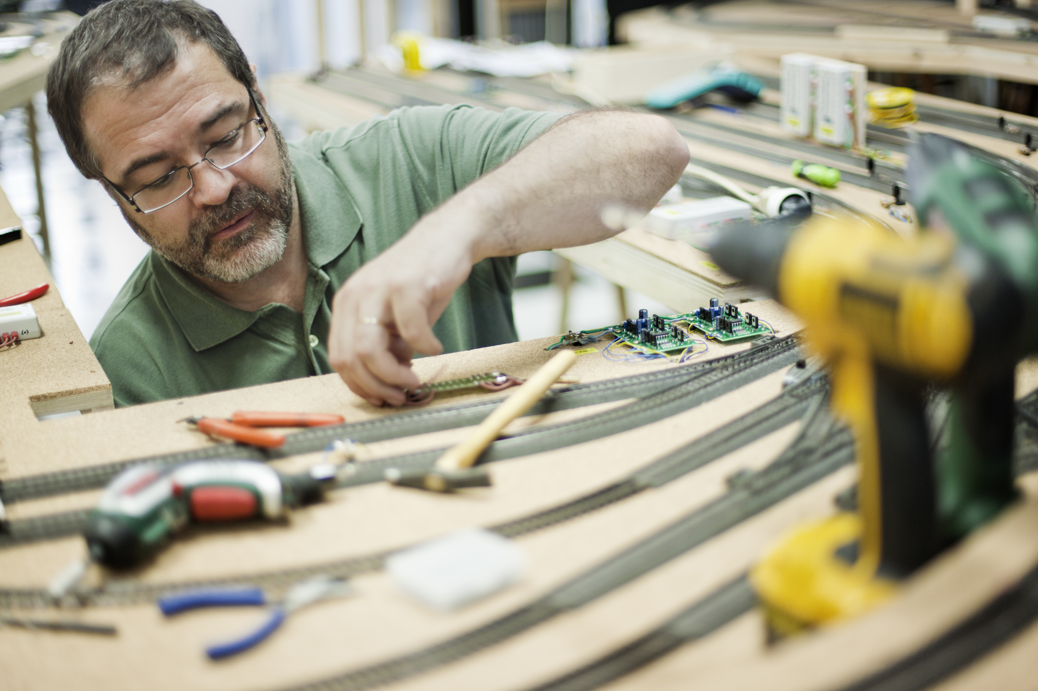

How do I contact the Area Group
* Replace NN with the number of your area group - get from the AG admin page. Update the contact form title. *
MERG South Hampshire Area Group contact form

Who are the leaders of the group?
Replace photo with the names and titles of leaders.
Chris Barker - Leader
Stuart Burgess - Deputy Leader

Would you like to join today?
Update area group name.
Not a member? then
Join MERG Here
and sign up to this Area Group. If you are already a member
Join the South Hampshire Area Group
Edit Area Groups using the green pencil. Then select South Hampshire Area Group from the drop down list in Other Area Groups and press the Subscribe to Area Group button.

How do you meet?
Provide meeting details
Whilst restrictions are in place, we are using Zoom video calls.
Previously we met at the Southampton Model Railway Society (SMRS). Meeting Venue: Unit 1b, Kemps Quay, Quayside Road, Southampton, SO18 1BZ.
Evening meetings took place on the 2nd Thursday of each month.
Workshop days normally take place on the 3rd Saturday of each month, unless we are representing MERG at an exhibition.
The club room is well equipped with several work benches, an open area with a 50“ screen that can be used for presentations and discussions, plus catering and toilet facilities.
It is situated on the first floor of an industrial unit. Access is by stairs but unfortunately there is no lift.
The meetings are flexible: You can build, test and fault find your electronic modules. Chris can assist you in developing your soldering skills. We can program the PICs used in MERG designs and have some basic test facilities for CBUS modules and DCC loco decoders and accessories. Presentations are welcome, and advice and guidance always available.
We are assisting in rebuilding one of the Southampton MRS exhibition layouts to enhance its operational capabilities and possibly add some animations.
The layout is being controlled by MERG CBUS and DCC modules. It will be controlled using route selection from a single control panel and one or two CANCABs will be used for loco control.

And the Next Meeting?
* Replace NN with the number of your area group - get from the AG admin page. Update the contact form title. *

Local Links
Link to local model railway sites.
Southhampton Model Railway Society

MERG South Hampshire (Southampton) Area Group
Return to Area Groups News
Index to other public pages
MERG Home page
Chris Barker (M4638) has arranged with the Southampton Model Railway Society (SMRS) for MERG members to be able to meet at their clubroom. Meeting Venue: Unit 1b, Kemps Quay, Quayside Road, Southampton, SO18 1BZ.
Evening meetings take place on the 2nd Thursday of each month.
Workshop days normally take place on the 3rd Saturday of each month, unless we are representing MERG at an exhibition.
The club room is well equipped with several work benches, an open area with a 50“ screen that can be used for presentations and discussions, plus catering and toilet facilities.
It is situated on the first floor of an industrial unit. Access is by stairs but unfortunately there is no lift.
The meetings are flexible: You can build, test and fault find your electronic modules. Chris can assist you in developing your soldering skills. We can program the PICs used in MERG designs and have some basic test facilities for CBUS modules and DCC loco decoders and accessories. Presentations are welcome, and advice and guidance always available.
We are assisting in rebuilding one of the Southampton MRS exhibition layouts to enhance its operational capabilities and possibly add some animations.
The layout is being controlled by MERG CBUS and DCC modules. It will be controlled using route selection from a single control panel and one or two CANCABs will be used for loco control.
We just missed the Southampton show, despite an extra session working on the control system. The scenic section is a complicated layout with three interconnected reversing loops using DCC unfriendly points, so accurate timing and sequencing is required to avoid shorts.

Scheduled meetings
All meetings cancelled until further notice
The July 2020 meetings will be on:
The evening of Thursday 9th July starting at 7.30pm. The club will be open from 7pm.
The all day workshop will be on Saturday 18th July. The club will be open from 09.45am.
The August 2020 meetings will be on:
The evening of Thursday 13th August starting at 7.30pm. The club will be open from 7pm.
The all day workshop will be on Saturday 15th August. The club will be open from 09.45am.

Exhibitions
If you cannot get to the meetings, you can come and meet us at one of the following exhibitions where we will be manning the MERG stand.
Portsmouth Model Railway Exhibition – Postponed
Saturday 4th April 10:30 - 18:00 and Sunday 5th April 10:30 - 16:30
At Mountbatten Leisure Centre, Portsmouth, Hampshire, P02 9QA
expoEM Spring 2020 – Cancelled
Saturday 16th May 10:30 – 17:30 and Sunday 17th May 10:00 - 16:30
At Bracknell Leisure Centre, Bagshot Road, Bracknell, RG12 9SE.
Fareham and District MRC Annual Exhibition CANCELLED
Saturday 3rd October 10:30 – 17:00 and Sunday 4th October 10:00 - 16:00
At Fareham Leisure Centre, Park Lane, Fareham, PO16 7JU.
Farnham and District MRC Annual Exhibition CANCELLED
Saturday 10th October 10:30 – 17:00 and Sunday 11th October 10:00 - 16:00
At Alderwood Leisure Centre, Tongham Road, Aldershot, GU12 4AS.

Contacts
Contact Chris for more informationvia profile page
Non member enquiries via MERG Area-Groups page
For more information on the Southampton MRS, go to their Web site SMRS website

