Replace Somewhere with the name of your area group.

MERG Wales North Area Group
Area Groups Public pages MERG Home page
Replace photo with a area group meeting photo
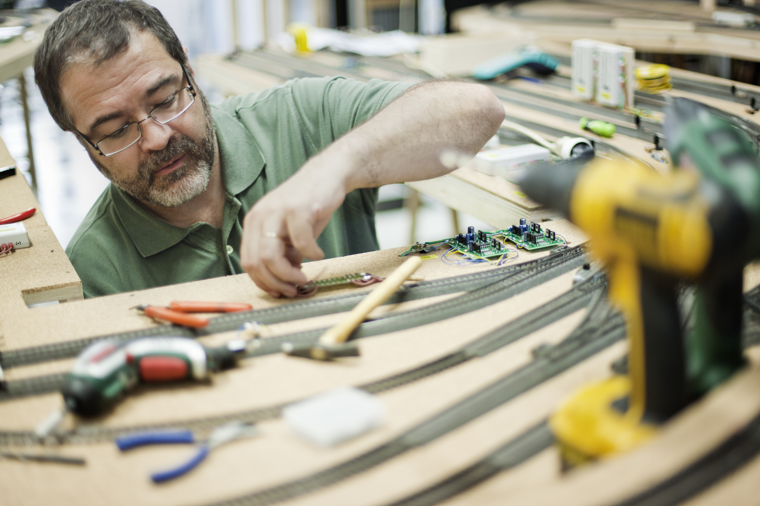

How do I contact the Area Group
Please indicate Wales North Area Group in your message Contact MERG

Who are the leaders of the group?
Replace photo with the names and titles of leaders.
John Farrell
Anthony Hoath

Would you like to join today?
Update area group name.
Not a member? then
Join MERG Here
and sign up to this Area Group. If you are already a member
Join the Wales North Area Group
Select Wales North Area Group from the drop down list in Other Area Groups and press the Subscribe to Area Group button.

How do you meet?
Provide meeting details
The new group covers a large geographic area and to begin with we will use Zoom video calls. Once we have the group up and running and once we can safely meet again, we will organise some physical meetings.
We will start by agreeing among ourselves, what we want to achieve . I am especially keen on finding ways to help members get the most out of their MERG membership and especially helping newcomers to electronics to get started by building some simple MERG kits. “

And the Next Meeting?
* Replace NN with the number of your area group - get from the AG admin page. Update the contact form title. *
Wales North Members Pages

